CERTIFICATION OF PLACEMENT OF
HULL IDENTIFICATION NUMBERS

You have been issued the following hull identification number, which MUST be affixed to your vessel within 30 days of issuance pursuant to STATE LAW
... ,,. Z ____ ____
(Be sure to include the “++Z” at the beginning of your hull ID number on your vessel.)

- Burn, carve, stamp, emboss, mold, bond, or otherwise permanently affix each hull identification number to transom or gunwale of the vessel in a manner that ensures any alteration, removal, or replacement will be obvious.
- Ensure the characters of each hull identification number affixed to the vessel are no less than ¼ inch in height.
- Permanently affix the hull identification number as follows:
- On vessels with transoms, affix the hull identification number to the right or starboard side of the transom within two inches of the top of the transom or hull/deck joint, whichever is lower.
- On vessels without a transom, affix the hull identification number to the starboard outboard side of the hull, back or aft within one foot of the stern and within two inches of the top of the hull, gunwale or hull/deck joint, whichever is lowest.
- On a catamaran or pontoon boat, affix the hull identification number on the aft crossbeam within one foot of the starboard hull attachment.
- As close as possible to the applicable location established under subsections (a), (b), or (c) when rails, fittings, or other accessories obscure the visibility of the hull identification number.
Return this form or a picture of the hull identification number within 30 days to:
(AGENCY)
(Address) OR Email to: EMAIL ADDRESS
(City, State, Zip Code)

I, the undersigned,__________________________________, do hereby declare that I am the legal owner of the vessel STATE Registration: ** ____________ and that the statements made by me in this affidavit or in any documents attached hereto are true and complete to the best of my knowledge and belief. I further attest that I applied the State assigned Hull Identification Number as required.
Signature of Affiant: Date: / /
STATE LAW CODE; “A person who knowingly and willfully makes a false, fictitious or fraudulent statement…in any manner within the jurisdiction of any department or agency of state government…shall, upon conviction thereof, be punished by a fine of not more than $1000 or by imprisonment for not less than five years, or both.”

(print name)

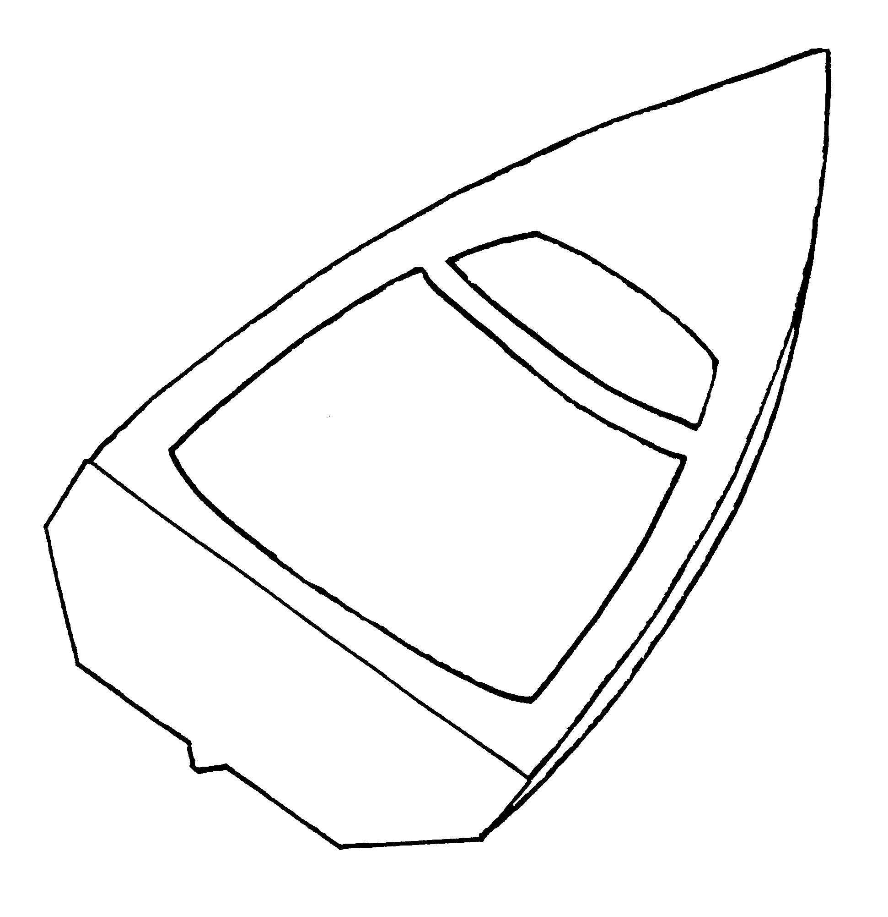

--Z ##### ####

ADD STATE LAW ABOUT HIN AND ILLEGAL OPERATION WITHOUT A HIN AND ILLEGAL TO SELL OR BUY WITHOUT A HIN.

